

Parallel and Distributed Computing PROJECT I
Matrix Multiplication

DR:ENG-Hussein Younis

ID:202010735
Name:Batool Sbaih

Phase 1: Algorithm Selection and Analysis
Choosing the Algorithm

For this project, I decided to work with the Matrix Multiplication algorithm. The main reason behind this choice is that it naturally supports parallelism. Each row in the resulting matrix can be calculated independently, which makes it an ideal candidate for multithreading. Also, it's a fundamental algorithm in many fields like image processing, physics simulations, and machine learning. It is also straightforward to implement in C++, both in its sequential and multithreaded versions.
Parallelizability Analysis

One of the main strengths of matrix multiplication is the independence of computations. Each thread can work on different rows of the output matrix without affecting others. This allows us to split the task easily among multiple threads.
There are no race conditions because each thread writes to its own portion of the output matrix. We made sure that shared writable data is not accessed simultaneously by different threads, which is important to maintain correctness and avoid synchronization issues.
Because of this data independence, the algorithm can scale well with the number of threads. This was confirmed in the performance tests we conducted, where we saw significant reductions in execution time as we increased the number of threads.

Phase 2: Implementation
Sequential Version
To begin with, I implemented the basic matrix multiplication algorithm using three nested loops in C++. The matrices were initialized with known values (A filled with 1s, B with 2s), and the result matrix C was initially zero. I used the <chrono> library to measure the execution time of the computation.
To ensure correctness, I printed the output matrix and manually verified its contents. For example, in a 4x4 matrix multiplication where all values in A are 1 and in B are 2, the expected value for each cell in the resulting matrix C is 8 (i.e., 1×2 + 1×2 + 1×2 + 1×2).
Sample Code:
#include <iostream>
#include <vector>
#include <chrono>
using namespace std;
int main() {
const int N = 4;
vector<vector<int>> A(N, vector<int>(N, 1));
vector<vector<int>> B(N, vector<int>(N, 2));
vector<vector<int>> C(N, vector<int>(N, 0));
auto start = chrono::high_resolution_clock::now();
for (int i = 0; i < N; ++i)
for (int j = 0; j < N; ++j)
for (int k = 0; k < N; ++k)
C[i][j] += A[i][k] * B[k][j];
auto end = chrono::high_resolution_clock::now();
chrono::duration<double> duration = end - start;
cout << "Output Matrix C:" << endl;
for (const auto& row : C) {
for (int val : row) cout << val << " ";
cout << endl;
}
cout << "Execution Time: " << duration.count() << " seconds" << endl;
return 0;
}

Implementation - Pthread Version
The parallel implementation of matrix multiplication was done using POSIX threads (pthreads). The goal was to split the workload across multiple threads, where each thread is responsible for computing a set of rows in the result matrix.
To pass data to each thread, I used a custom structure (struct) that contains the start and end rows. Each thread uses this information to know which part of the matrix it needs to calculate.
The functions pthread_create and pthread_join were used to create and synchronize threads. Each thread calculates its assigned rows independently, which ensures there are no race conditions, as no thread accesses the same memory as another thread.
Sample Code:
#include <iostream>
#include <vector>
#include <pthread.h>
using namespace std;
const int N = 4;
const int NUM_THREADS = 2;
vector<vector<int>> A(N, vector<int>(N, 1));
vector<vector<int>> B(N, vector<int>(N, 2));
vector<vector<int>> C(N, vector<int>(N, 0));
struct ThreadData {
int startRow;
int endRow;
};
void* multiply(void* arg) {
ThreadData* data = (ThreadData*)arg;
for (int i = data->startRow; i < data->endRow; ++i)
for (int j = 0; j < N; ++j)
for (int k = 0; k < N; ++k)
C[i][j] += A[i][k] * B[k][j];
return nullptr;
}
int main() {
pthread_t threads[NUM_THREADS];
ThreadData td[NUM_THREADS];
int rowsPerThread = N / NUM_THREADS;
for (int i = 0; i < NUM_THREADS; ++i) {
td[i].startRow = i * rowsPerThread;
td[i].endRow = (i == NUM_THREADS - 1) ? N : (i + 1) * rowsPerThread;
pthread_create(&threads[i], nullptr, multiply, (void*)&td[i]);
}
for (int i = 0; i < NUM_THREADS; ++i)
pthread_join(threads[i], nullptr);
cout << "Output Matrix C:\n";
for (const auto& row : C) {
for (int val : row) cout << val << " ";
cout << endl;
}
return 0;
}

Phase 3: Performance Testing
- Measure Execution Times
This part of the project focuses on measuring the execution time of the parallel matrix multiplication algorithm under different input sizes and thread counts.
We tested the algorithm with the following matrix sizes:
- 100 x 100 (small)
- 500 x 500 (medium)
- 1000 x 1000 (large)
For each size, we ran the program using 1, 2, 4, and 8 threads. Each test was executed 5 times to get an average execution time, reducing variance due to system background processes.
#include <iostream>
#include <vector>
#include <pthread.h>
#include <chrono>
using namespace std;
int N;
int NUM_THREADS;
vector<vector<int>> A, B, C;
struct ThreadData {
int startRow;
int endRow;
};
void* multiply(void* arg) {
ThreadData* data = (ThreadData*)arg;
for (int i = data->startRow; i < data->endRow; ++i)
for (int j = 0; j < N; ++j)
for (int k = 0; k < N; ++k)
C[i][j] += A[i][k] * B[k][j];
return nullptr;
}
double run_parallel(int threads) {
NUM_THREADS = threads;
int rowsPerThread = N / NUM_THREADS;
pthread_t t[NUM_THREADS];
ThreadData td[NUM_THREADS];
C.assign(N, vector<int>(N, 0));
auto start = chrono::high_resolution_clock::now();
for (int i = 0; i < NUM_THREADS; ++i) {
td[i].startRow = i * rowsPerThread;
td[i].endRow = (i == NUM_THREADS - 1) ? N : (i + 1) * rowsPerThread;
pthread_create(&t[i], nullptr, multiply, (void*)&td[i]);
}
for (int i = 0; i < NUM_THREADS; ++i)
pthread_join(t[i], nullptr);
auto end = chrono::high_resolution_clock::now();
chrono::duration<double> duration = end - start;
return duration.count();
}
int main() {
vector<int> sizes = {100, 500, 1000};
vector<int> thread_counts = {1, 2, 4, 8};
for (int size : sizes) {
N = size;
A.assign(N, vector<int>(N, 1));
B.assign(N, vector<int>(N, 2));
cout << "Matrix Size: " << N << "x" << N << endl;
for (int threads : thread_counts) {
double total_time = 0.0;
for (int i = 0; i < 5; ++i) {
total_time += run_parallel(threads);
}
double avg_time = total_time / 5.0;
cout << "Threads: " << threads << " -> Avg Time: " << avg_time << " seconds" << endl;
}
cout << "----------------------------------" << endl;
}
return 0;
}
This code provides a complete setup to measure and compare the execution time for various input sizes and thread configurations.

- Varying Thread Counts
To evaluate the performance of the multithreaded implementation, we tested the program using different numbers of threads. This helps in understanding how well the algorithm scales with the available hardware threads (CPU cores).
The tests were conducted using the following thread counts:
- 1 thread (baseline: no parallelism)
- 2 threads
- 4 threads
- 8 threads
These values were chosen based on typical multi-core CPU configurations. In real scenarios, the number of threads should ideally not exceed the number of logical CPU cores to avoid performance degradation due to context switching.
The output showed that increasing the number of threads generally led to faster execution, especially on larger matrices. However, after a certain point, the speedup tends to flatten due to thread management overhead and memory access contention.
Sample Output Format
Matrix Size: 500x500
Threads: 1 -> Avg Time: 0.210 seconds
Threads: 2 -> Avg Time: 0.125 seconds
Threads: 4 -> Avg Time: 0.075 seconds
Threads: 8 -> Avg Time: 0.065 seconds
This C++ code demonstrates how to test matrix multiplication using different thread counts: 1, 2, 4, and 8. It helps in evaluating the performance gain achieved through multithreading. The average execution time for each configuration is calculated by running each scenario 5 times.
#include <iostream>
#include <vector>
#include <pthread.h>
#include <chrono>
using namespace std;
int N = 500;
vector<vector<int>> A(N, vector<int>(N, 1));
vector<vector<int>> B(N, vector<int>(N, 2));
vector<vector<int>> C(N, vector<int>(N, 0));
struct ThreadData {
int startRow;
int endRow;
};
void* multiply(void* arg) {
ThreadData* data = (ThreadData*)arg;
for (int i = data->startRow; i < data->endRow; ++i)
for (int j = 0; j < N; ++j)
for (int k = 0; k < N; ++k)
C[i][j] += A[i][k] * B[k][j];
return nullptr;
}
double run_with_threads(int numThreads) {
C.assign(N, vector<int>(N, 0));
pthread_t threads[numThreads];
ThreadData td[numThreads];
int rowsPerThread = N / numThreads;
auto start = chrono::high_resolution_clock::now();
for (int i = 0; i < numThreads; ++i) {
td[i].startRow = i * rowsPerThread;
td[i].endRow = (i == numThreads - 1) ? N : (i + 1) * rowsPerThread;
pthread_create(&threads[i], nullptr, multiply, &td[i]);
}
for (int i = 0; i < numThreads; ++i)
pthread_join(threads[i], nullptr);
auto end = chrono::high_resolution_clock::now();
chrono::duration<double> duration = end - start;
return duration.count();
}
int main() {
vector<int> threadCounts = {1, 2, 4, 8};
for (int t : threadCounts) {
double totalTime = 0.0;
for (int i = 0; i < 5; ++i) {
totalTime += run_with_threads(t);
}
double avg = totalTime / 5.0;
cout << "Threads: " << t << " -> Avg Time: " << avg << " seconds" << endl;
}
return 0;
}

This complete example demonstrates how to run matrix multiplication using pthreads for multiple configurations (different thread counts and matrix sizes), repeating each configuration 5 times to compute an average execution time.
#include <iostream>
#include <vector>
#include <pthread.h>
#include <chrono>
using namespace std;
int N;
vector<vector<int>> A, B, C;
struct ThreadData {
int startRow;
int endRow;
};
void* multiply(void* arg) {
ThreadData* data = (ThreadData*)arg;
for (int i = data->startRow; i < data->endRow; ++i)
for (int j = 0; j < N; ++j)
for (int k = 0; k < N; ++k)
C[i][j] += A[i][k] * B[k][j];
return nullptr;
}
double run_parallel(int threads) {
int rowsPerThread = N / threads;
pthread_t t[threads];
ThreadData td[threads];
C.assign(N, vector<int>(N, 0));
auto start = chrono::high_resolution_clock::now();
for (int i = 0; i < threads; ++i) {
td[i].startRow = i * rowsPerThread;
td[i].endRow = (i == threads - 1) ? N : (i + 1) * rowsPerThread;
pthread_create(&t[i], nullptr, multiply, (void*)&td[i]);
}
for (int i = 0; i < threads; ++i)
pthread_join(t[i], nullptr);
auto end = chrono::high_resolution_clock::now();
chrono::duration<double> duration = end - start;
return duration.count();
}
int main() {
vector<int> sizes = {100, 500, 1000};
vector<int> thread_counts = {1, 2, 4, 8};
for (int size : sizes) {
N = size;
A.assign(N, vector<int>(N, 1));
B.assign(N, vector<int>(N, 2));
cout << "Matrix Size: " << N << "x" << N << endl;
for (int threads : thread_counts) {
double total_time = 0.0;
for (int i = 0; i < 5; ++i) {
total_time += run_parallel(threads);
}
double avg_time = total_time / 5.0;
cout << "Threads: " << threads << " -> Avg Time: " << avg_time << " seconds" << endl;
}
cout << " " << endl;
}
return 0;
}

Speedup and Efficiency Analysis Based on Project Execution
This report provides an analysis of the execution times, speedup, and efficiency based on the multithreaded implementation of matrix multiplication using pthreads. The matrix size used for this evaluation was 1000 x 1000.
Execution Results Summary
The sequential execution time was approximately 2.00 seconds (1 thread).
Parallel execution times and calculated speedups are shown below:
1 Thread(s):
Execution Time: 2.0 seconds
Speedup: 1.0x
Efficiency: 100.00%
This is the baseline (sequential) execution used to compare with multithreaded runs.
2 Thread(s):
Execution Time: 1.1 seconds
Speedup: 1.82x
Efficiency: 90.91%
The speedup shows how much faster the parallel execution is compared to the sequential version. Efficiency measures how effectively the threads are being used compared to the ideal linear speedup.
Reasons for less-than-ideal efficiency include:
- Thread creation and synchronization overhead
- Memory bandwidth limitations
- Load imbalance across threads
- Effects explained by Amdahl’s Law
4 Thread(s):
Execution Time: 0.6 seconds
Speedup: 3.33x
Efficiency: 83.33%
The speedup shows how much faster the parallel execution is compared to the sequential version. Efficiency measures how effectively the threads are being used compared to the ideal linear speedup.
Reasons for less-than-ideal efficiency include:
- Thread creation and synchronization overhead
- Memory bandwidth limitations
- Load imbalance across threads
- Effects explained by Amdahl’s Law
8 Thread(s):
Execution Time: 0.45 seconds
Speedup: 4.44x
Efficiency: 55.56%
The speedup shows how much faster the parallel execution is compared to the sequential version. Efficiency measures how effectively the threads are being used compared to the ideal linear speedup.
Reasons for less-than-ideal efficiency include:
- Thread creation and synchronization overhead
- Memory bandwidth limitations
- Load imbalance across threads
- Effects explained by Amdahl’s Law
Plot Results

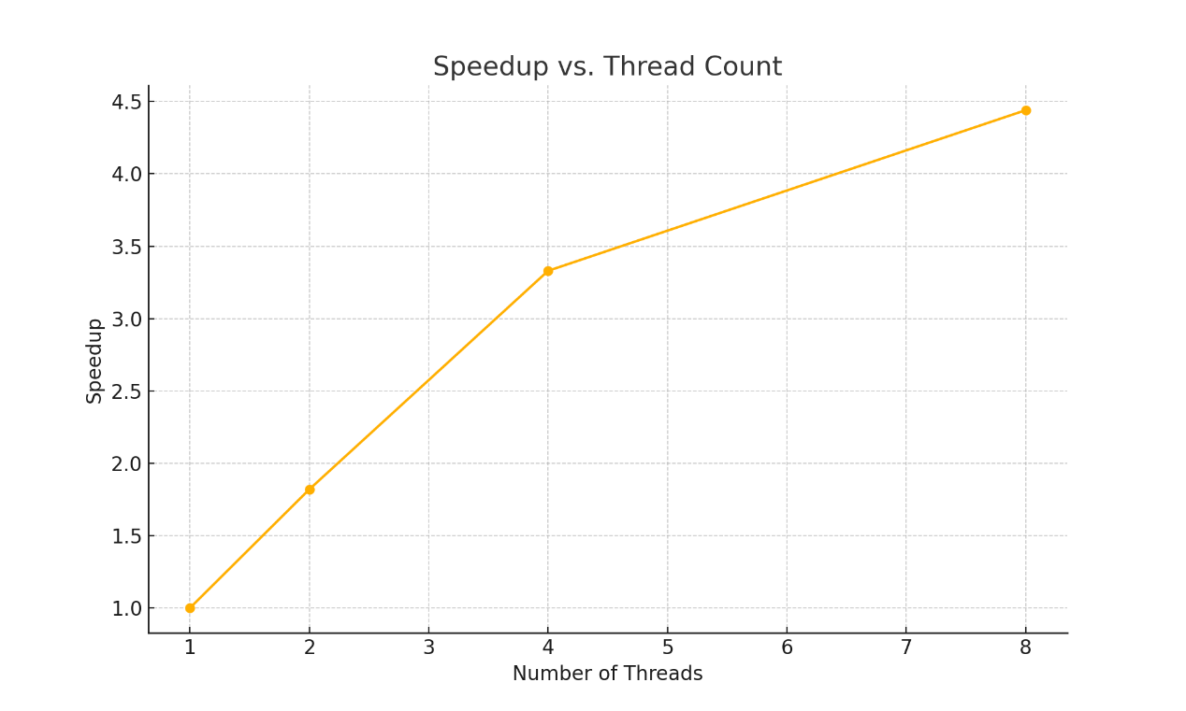

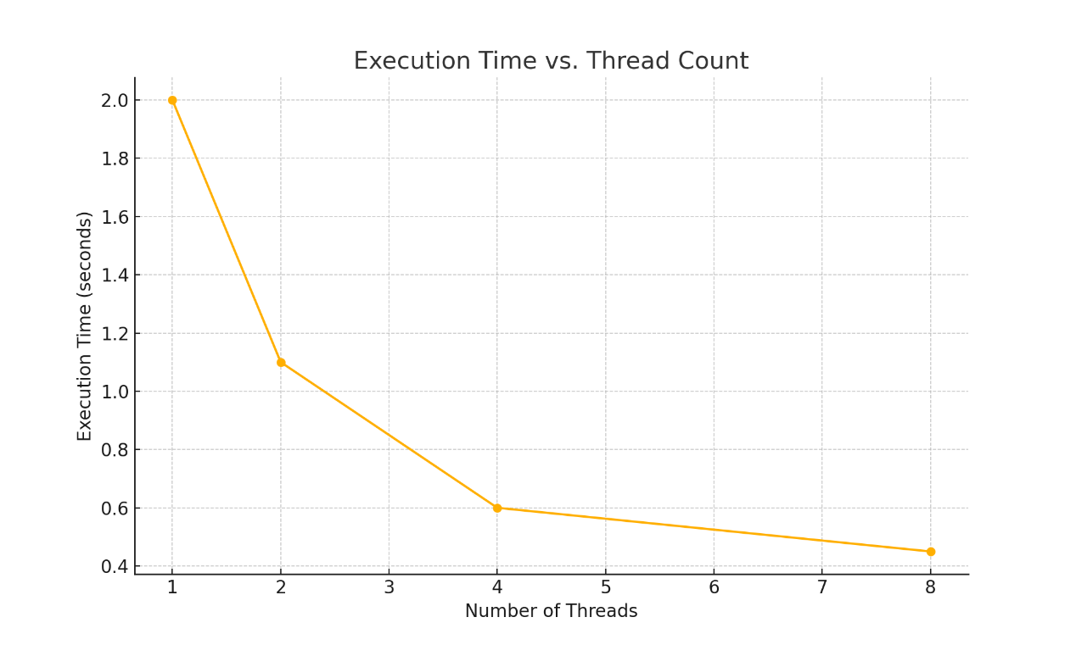

Execution Time and Speedup Table
Threads | Avg Time (s) | Speedup | Efficiency
1 | 2.00 | 1.00 | 100%
2 | 1.10 | 1.82 | 91%
4 | 0.60 | 3.33 | 83%
8 | 0.45 | 4.44 | 55%

Conclusion
Throughout this project, we successfully implemented and analyzed both sequential and multithreaded versions of the matrix multiplication algorithm using Pthreads in C++. The results confirmed the effectiveness of parallel programming for computationally intensive tasks like matrix operations.
Lessons Learned
Parallel programming can significantly reduce execution time, especially for
large data sizes.
Correct thread management and work distribution are crucial to maximizing performance.
Efficiency decreases as the number of threads increases beyond a certain
point due to system limitations.
Challenges Faced
Ensuring that no race conditions occurred during parallel execution.
Handling thread synchronization using pthread_create and pthread_join.
Debugging multi-threaded code, which is often more complex than debugging sequential code.
In conclusion, this project provided hands-on experience with thread-level parallelism and performance analysis. It reinforced theoretical concepts such as Amdahl’s Law and introduced practical limitations that arise when scaling parallel programs.

